**Questions**

* Given the provided data, what are three conclusions that we can draw about crowdfunding campaigns?
  + Based on our data sample, 56.5% of campaigns are successful while 36.4% are failed and 5.7% are cancelled, meaning that the chances of a crowdfunding campaign succeeding is just over half.
  + The theater parent category has the highest grand total, but the percentage of failed campaigns is still quite high.
  + The 1000 to 4999 goal range is the most likely to be successful based on sample size and percentage successful.
  + A campaign launched in July seems to have the highest rate of success while April and November have the lowest.
* What are some limitations of this dataset?
  + Sample size is too small to be able to draw conclusions
  + Not enough information about the campaigns (in the blurb column). With additional information we could develop a better understanding of the shared characteristics of successful campaigns and failed campaigns.
* What are some other possible tables and/or graphs that we could create, and what additional value would they provide?
  + Success rate per category would be a useful table. When we see the theater category in the pivot table, we might immediately think it’s the most successful since it has the highest total amount of campaigns but it doesn’t have the highest success rate.
  + Table that allows us to analyze the amount of time that the campaign was live. If a campaign is open/live for a longer period of time, it probably has a higher success rate as there is more time for backers to contribute.

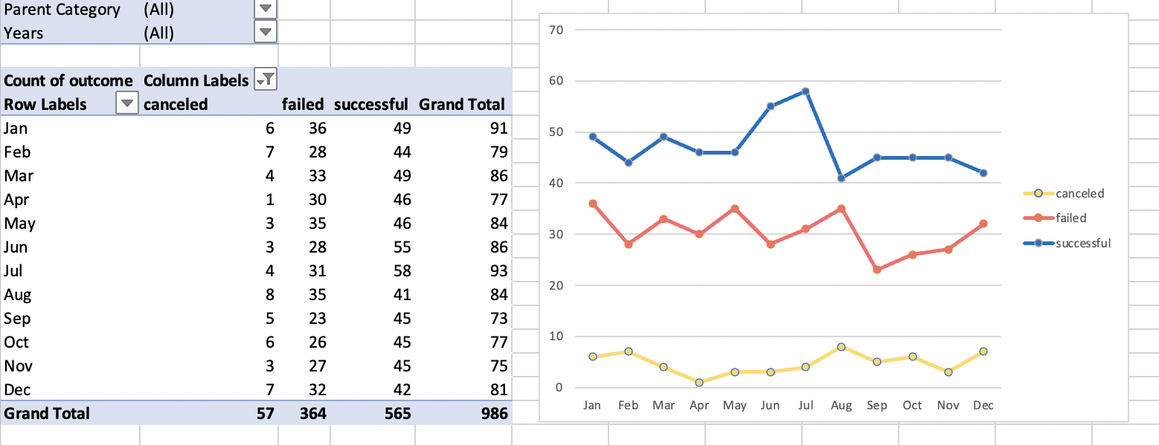

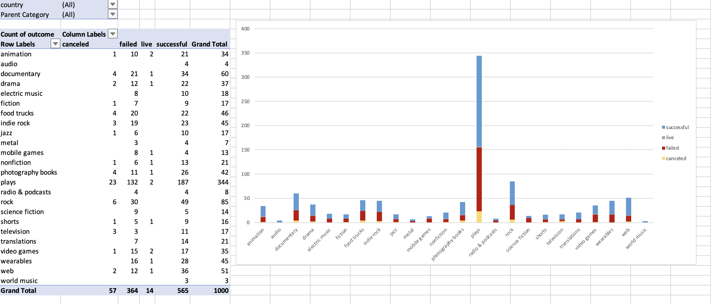

Use your data to determine whether the mean or the median better summarizes the data.

* + The median better summarizes the data because the distribution of the data is very skewed. The mean will also be skewed by the outliers as shown in the histogram below. Most of the campaigns fall into the first bucket.

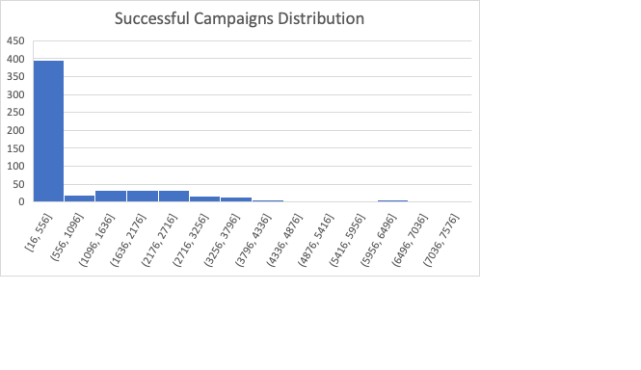

Use your data to determine if there is more variability with successful or unsuccessful campaigns. Does this make sense? Why or why not?

* The standard deviation of successful campaigns (1266.24) is higher than the failed campaigns (959.99), meaning there is more variability.

